Interactive Infographics

Project Setup:
1. Navigate to - https://github.com/Ayeshaq09/Unified-mentor-projects You will see all 8 projects.
2. To get the projects onto your system: click on "Code" button and copy the link - https://github.com/Ayeshaq09/Unified-mentor-projects.git
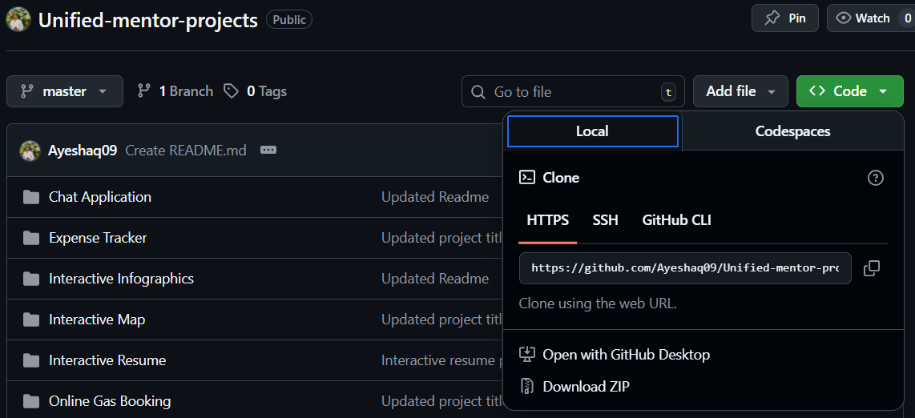
3. Open git bash and run the following command:
git clone https://github.com/Ayeshaq09/Unified-mentor-projects.git

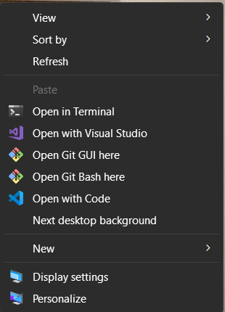
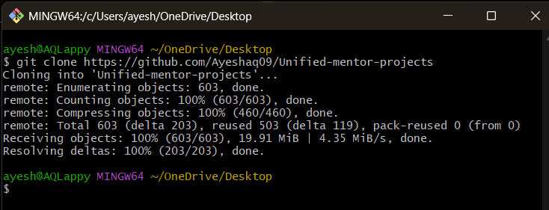
4. Once cloning is done, you get all the 8 projects onto your system.

About the project:
This project presents interactive infographics on global air pollution using line chart and images.

Features:
- Interactive charts, images and sliders for exploring data.
- Mobile-responsive, clean design.

Technologies Used
- HTML5, CSS3, JavaScript
- Chart.js for the graph
- JSON dataset

Interactive infographics project setup:
1.Open the folder in vscode and in terminal run – npx http-server
Ctrl+click on “Available on” links to open the application in browser.
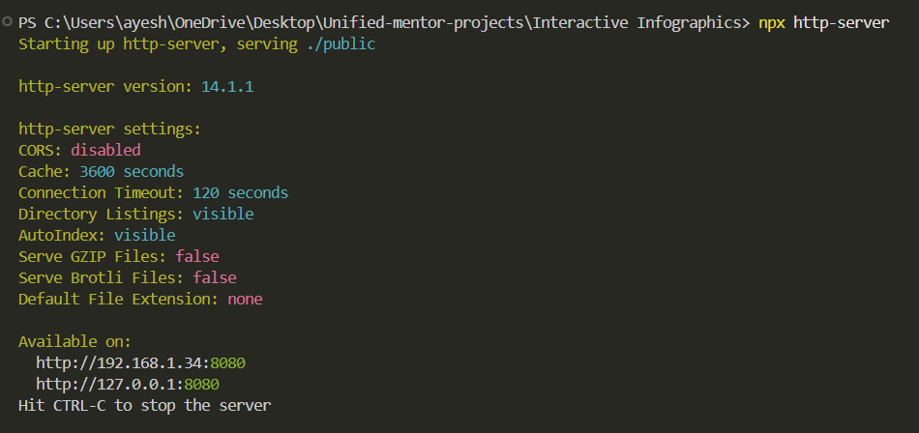

Functionality of the application:
1. The first section shows "World air pollution line chart" that display deaths due to 4 different types of air pollution over the years (1990-2025).

Hover over the lines to see the tooltip. It also has a slider to navigate through the years. When you reach the year 2025 on the slider, the line graph changes to horizontal bar graph that has a tooltip (hover over the bars) and displays average of the air pollution over years.

You can also click play button to see the animation for the graph.
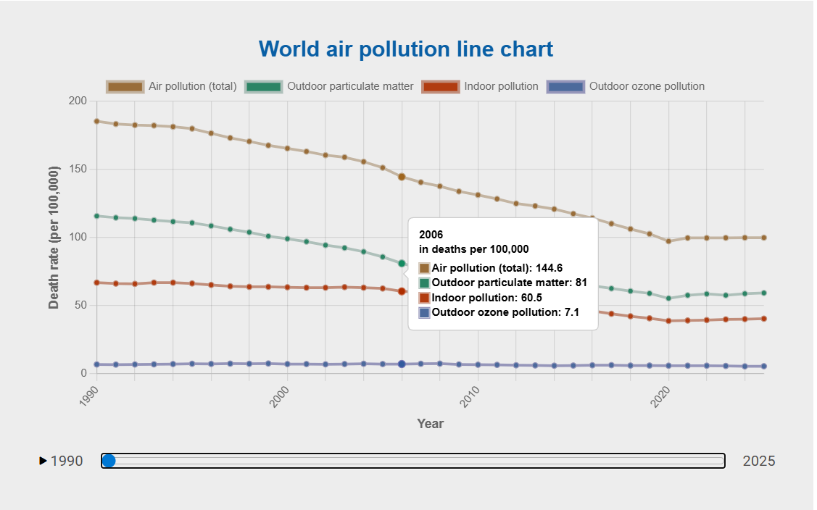

2. The next section displays "types of air pollution". Hover and click to reveal more details about each. Hover over the detail section as well for the
transition effect.
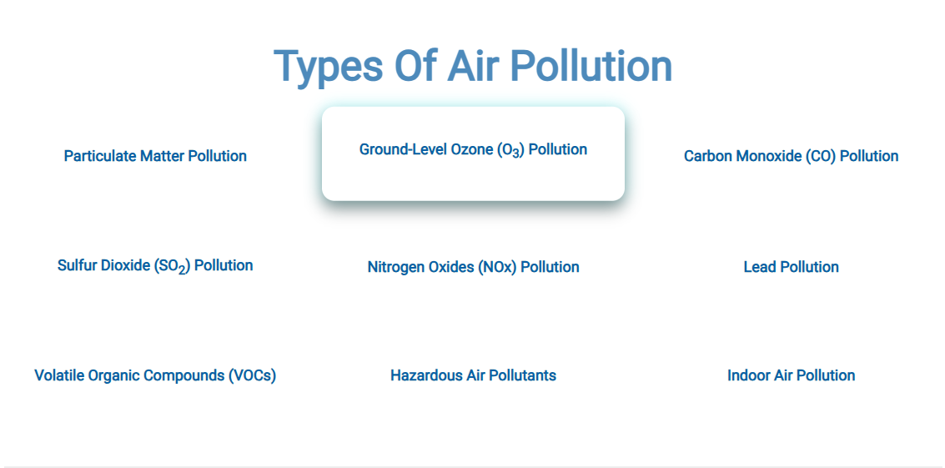
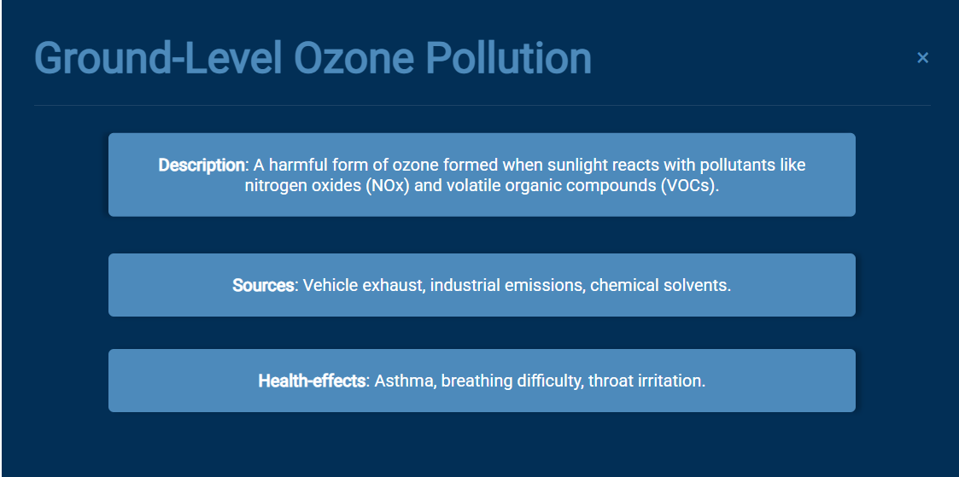

3.Next section displays “Causes of air pollution”.
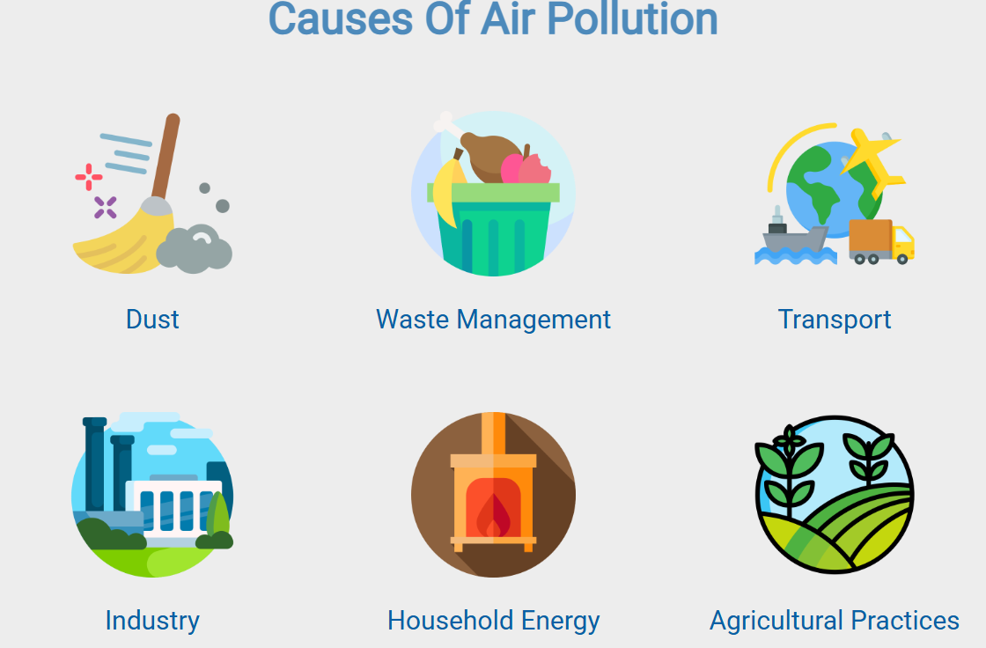

4. The fourth section displays "Health effects of air pollution".
Click over the points to reveal the health effect corresponding to the respective
body organ due to air pollution.
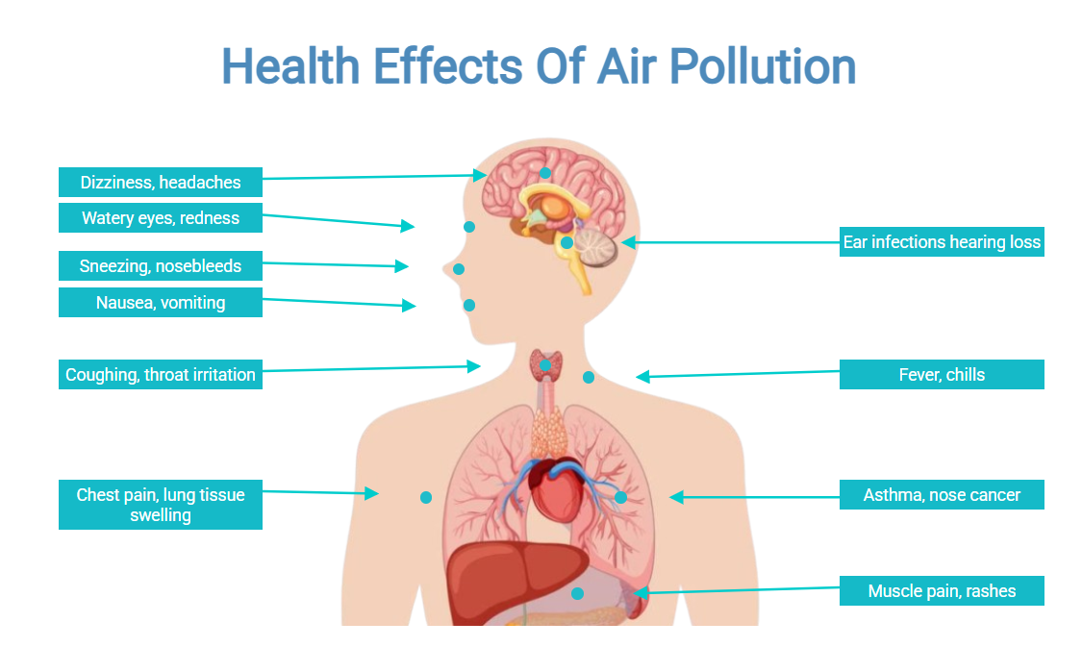

5. Last section displays “Ways to prevent air pollution”.
Hover over the images for the transition effect.
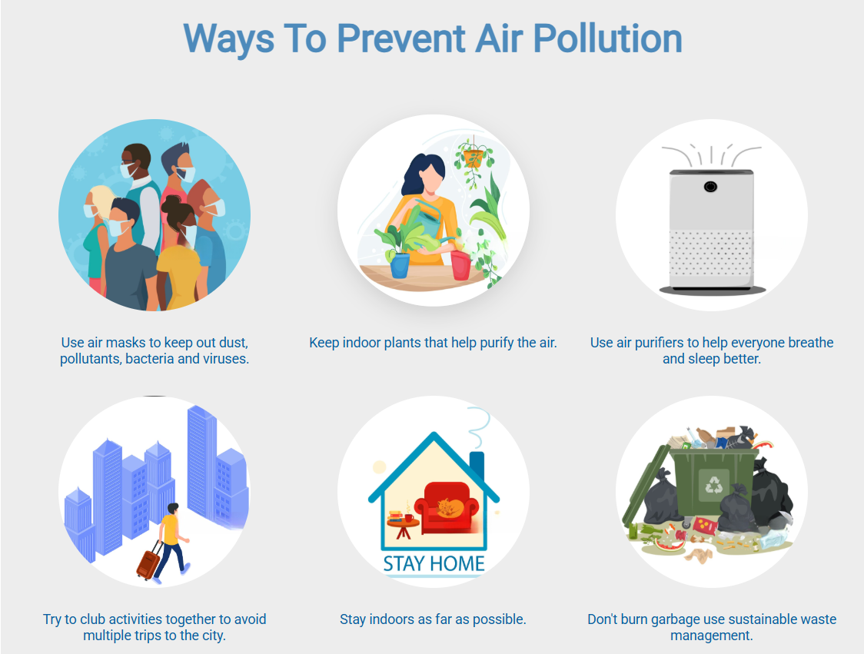
5. Resize the screen to check the responsiveness of the application.

